**NOTIFIER FOR ABNORMAL PULSE RATE**

**Sudhanshu Shukla** B.Tech (Scholar) Department of Computer Science & Engineering, Shri Shankaracharya Institute of Professional Management and Technology, Raipur, Chhattisgarh, India  
sudhanshu.shukla@ssipmt.com

**Preeti Tuli**   
Assistant Professor  
Department of Computer Science & Engineering,  
Shri Shankaracharya Institute of Professional Management and Technology, Raipur, Chattisgarh, India   
p.tuli@ssipmt.com

**Anjali Jha**   
B.Tech (Scholar)  
Department of Computer Science & Engineering,  
Shri Shankaracharya Institute of Professional Management and Technology, Raipur, Chattisgarh, India anjali.jha@ssipmt.com

**Simran Banarase**  B.Tech (Scholar) Department of Computer Science & Engineering, Shri Shankaracharya Institute of Professional Management and Technology, Raipur, Chhattisgarh, India  
simran.banarase@ssipmt.com

**ABSTRACT-**

According to a survey by WHO, 8% of death all over the world causes due to respiratory issues. It is causing due to genetics, smoking, pollution, and burning biomass fuel. As we know many individuals have lost their lives during the COVID-19 period, especially at the point when doctors cannot physically meet and treat the patients until the situation is more critical. Keeping all this point in mind we have developed a system using IoT to monitor individual health by tracking the heart rate of one. In this way, we are providing the solution to the one having respiratory issues and helping them to get more appropriate treatment over time.

**KEYWORDS –** Internet of Things, Wi-Fi Module, Arduino Mega, Application Programming Interface, Healthcare

1. **INTRODUCTION**

An abnormal pulse rate impairs blood circulation in the body. As a result, less oxygen reaches different parts of the body, affecting internal organs damage [1]. As we know, an abnormal pulse rate is harmless and causes uncomfortable symptoms such as chest pain, dizziness, fainting, weakness, and shortness of breath..during lockdown period (i.e. coronavirus period) Physicians cannot see and treat patients in person until the situation is critical [2]. The COVID-19 pandemic has created many problems for everyone. In particular, patients whose heart rates need to be monitored regularly by their attending physicians have been affected by this COVID-19 epidemic. This narrows the communication gap between patients and physicians/caregivers [5]. The introduction of lockdowns around the world has also exacerbated the situation for patients. So our communication gap/bridge between patients and doctors. We have built a system that allows The system uses a sensor that calculates a person’s or patient’s heart rate when a finger is placed on it. We used highly reliable components such as the Arduino Mega 2560 board, which is the system's brains, a heart rate IR sensor that detects your body’s heart rate, and a BOLT Wi-Fi module connecting to send data over the internet.[7] . I used VS code to run the program (code) needed to detect anomalies present in the heartbeat [2].

1. **LITERATURE SURVEY**

This document focuses on heart rate monitors and alarms that allow you to see the patient’s heart rate status. The framework determines heart rate per minute and sends an SMS notification to mobile phones. It’s a great, easy-to-use framework that offers great flexibility. This way and is a huge improvement over other traditional monitoring and alerting systems. The design of this paper consistently observes human heart rate. Receive signals from your body and send an SMS to your specialist. Since these are relative, treatment can be given within the period of cardiovascular damage. Life is worth it to many, but it’s breathtakingly unlucky among us. Regular health checks using this framework can reduce the chance of having a heart attack. The system checks the body parameters such as heart rate and sends appropriate data to the web Used for clear transmission to the authorities via the application. The system includes an IR-based heart rate sensor and an Arduino Mega board. Looking back on heartbeats from children to the elderly. With very little effort on the device, the post-activation verification structures are given in proper order. “Heart Rate Monitoring System with Heart Rate Sensor and Arduino”. In this effort, heartbeats can be discreetly identified with the Arduino as development progresses. This work is based on patient observations that are routinely made by specialists without physical patient visits. In this paper, IoT will be a critical phase for some administrators and applications.  
A patient’s pulse can be checked by a specialist or caregiver without physically visiting the patient. Professionals can then provide expedited services remotely or at the patient’s request. The framework is updated with a heart rate sensor, Arduino Mega, and Bolt Wi-Fi. The framework monitors physical parameters such as heartbeats and legally sends intentional information to the expert via her SMS. This framework includes an IR-based heartbeat sensor, an Arduino Mega, and a Wi-Fi module. This gadget can quantify heart rates in newborns to the elderly. The gadget’s simplicity provides a successful validation framework for a real command post. However, the method described is limited to a specific application and poses some problems for heart rate measurement. This strategy shows promising results and is useful for further imaging systems. The main goal of this article is to plan and build a framework for remotely monitoring heart rate and playing music that relies on the melody of the heartbeat to recommend an exercise system. The heart rate sensor circuit is intended to obtain heartbeats per minute (bpm). The output of the sensor is sent to the Arduino Ethernet Shield’s web server. Individuals can remotely check the physical status of their patents via the Internet. Heart rate is obtained from the heart rate sensor. This paper examines a remote monitoring system for observing abnormal electrocardiographic signals and communicating information naturally via cell phone messages.

1. 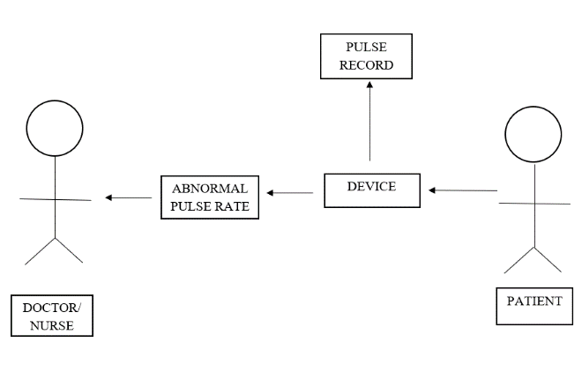**USE CASE DIAGRAM**

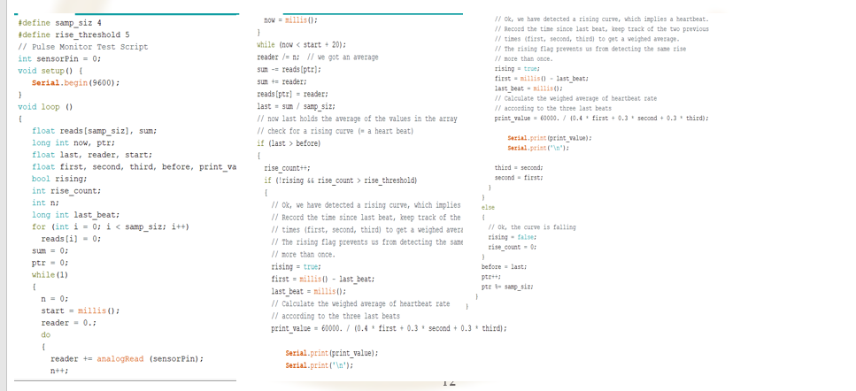

**Figure 1: Use Case Diagram**

1. **METHODOLOGY**

Our Abnormal Pulse Rate Detector project focused primarily on the communication gap between patients and physicians/caregivers during the COVID-19 lockdown period and in case of future pandemics. It’s dangerous to meet For this purpose (i.e. device), we used the Telegram bot as an online SMS service (i.e. alert message) to send heartbeat notifications from the patient to the doctor/caregiver. Uses a sensor to detect the patient’s pulse rate, when the patient’s finger is placed on the pulse sensor, there is an LED on the finger that emits ultraviolet light, which detects the veins of the finger and changes where the blood flows. Its value is detected by a radiation sensor and the heart rate is calculated.

We also used an Arduino Mega as the main microcontroller for the system [3][6]. I used a Wi-Fi module to automate the system by connecting to the internet through this Wi-Fi module. All data displayed in the Arduino IDE is collected using the cloud. The cloud is connected to the AWS VS service and code is written to validate data coming out of the cloud. The code runs continuously until the user stops running it on her AWS [4][5]. Our system checks the patient’s heart pulse for any abnormalities and if any abnormalities are observed, our system uses the Telegram bot or SMS API service to send the concerned doctor the SMS form to send a message.

.

**Figure 2: Arduino Code**

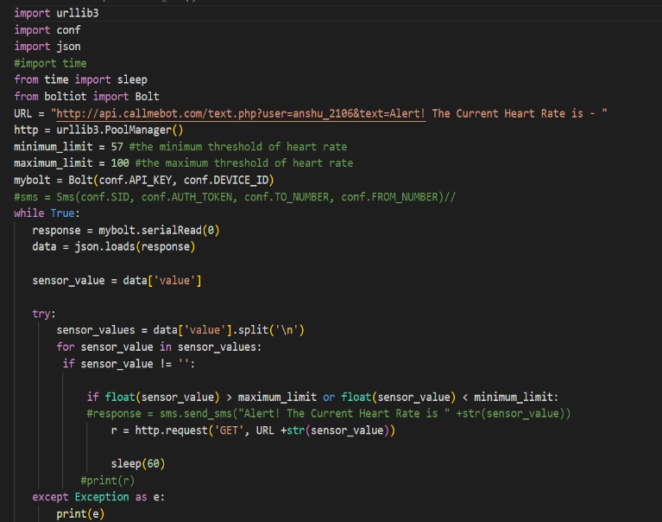

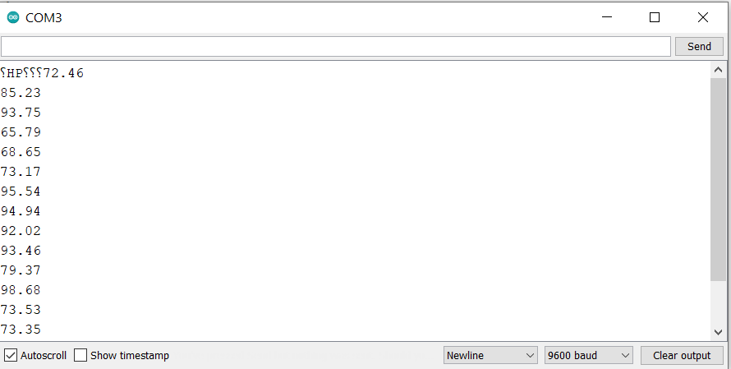**Figure 3: Python Programming (VS Code)**

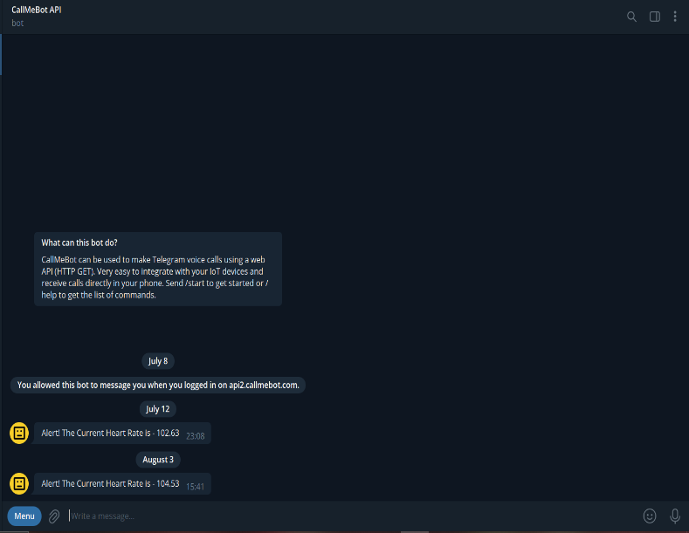 **Figure 4: Pulse Rate**

**Figure 5: Telegram Alert Message**

**V. CONCLUSION**

The main goal of our project is to build a communication bridge between patients and related healers/doctors. This will improve patient satisfaction with medical services.

Similarly, patients should avoid frequent phone calls and unscheduled visits to the doctor as a sign of respect for their time. Her 4,444 patients, whose heartbeats must be monitored regularly by their doctors, are particularly affected in the context of the pandemic. There is a communication gap between these patients and the physicians/caregivers involved.

This is where our idea blossomed to help patient groups who need to monitor their heart rate regularly.

**VI. FUTURE SCOPE**

The future scope of our project will extend the project by collecting patient data (heart rate readings) to enable concerned physicians/caregivers to predict irregularities in the not-too-distant future. It's about helping doctors.

Data can be used for further treatment.

These data can also be used for showing post-medical conditions.

**REFERENCES**

[1] Remote Patients Monitoring System(Heartbeat and Temperature) using Arduino, Ruaha Shallal Abbas Anooz, Methodology -using IoT, IJSER, Volume 9, ISSN 2229-5518, August 2018.

[2] Internet of Things for Smart HealthCare: Technologies, Challenges, and Opportunities, Stephanie B. Baker, Wei Xiang, Ian Atkinson, IEEE Access, Volume-5, DOI:10.1109/ACCESS.2017.2775180, November 2017.

[3] A study on cloud-based Internet of Things: CloudIoT, Shaik Masthan Babu, A. Jaya Lakshmi, B. Thirumala, IEEE Access, DOI:10.1109/GCCT.2015.7342624, December 2015.

[4] On the Integration of Cloud Computing and Internet of Things, Alessio Botta, Walter de Donato, Valerio Persico, AntonioPescape,IEEEAccess,DOI:10.1109/FiCloud.2014.14, December 2014.

[5] Heartbeat Monitoring Using IoT, Sayan Banerjee, Souptik Paul, Rohan Sharma, Abhishek Brahma, IEEE Access, DOI:10.1109/IEMICON18.8614921, January 2019.

[6] Analysis of Heart Rate and Body Temperature from the wireless monitoring system using Arduino, MohammadDabbagh. Methodology–using IoT, Journal of Physics: ConferenceSeries, DOI:10.1088/1742-6596/1358/1/012041, Published–November 2019.

[7] Continuous Heart Rate and Body Temperature Monitoring System using Arduino UNO And Android device- Asaduzzaman Miah, Hussain Kabir, Siddiqur R Tanveer, M.A.H. Akhand. Methodology–using IoT, IEEE Access, Published–January 2016.